To: David Willy, Connor R. Gaudette

From: Nathan Krikawa, Nolan Hann

Date: 12/05/24

Re: Project Management Draft

1. Reflection
1.1 Successes
This section contains a list of our successes last semester regarding project management and team communication. Each list item includes a description of the item along with how and why it benefitted our project.
- Text communication:
  - Using each other's phone numbers for communication allowed us to talk often and quickly reply to each other regarding what we are currently working on and what we need to get done. This allowed us to work together real-time without needing to wait for meetings to discuss urgent issues.
- Task delegation:
  - Being a team of two, task delegation was presumably easier for us than larger teams, however we were able to efficiently split the workload of each deliverable between us and fulfil our roles sufficiently. As soon as we set our focus on a new task, we split the load and got to work. This also allowed us to work together and help each other without feeling burdened by the other.
- Deadline communication:
  - We often checked up on each other regarding deliverable deadlines and where we were and what we still needed to get done. This helped us understand the progress of each deliverable and allowed us to help the other whenever possible or necessary.
- Schedule honesty:
  - Being open and honest about our schedules and how much we believed we could get done and when allowed us to delegate tasks much more effectively, as we had enough mutual trust to pick up slack while knowing the other would do the same, if necessary, in the future.
- Deliverable honesty:
  - We often had open and honest communication about where we thought ourselves and the other could have done better and used that dialogue to improve the quality of our work. This is very important as an opportunity to speak our minds and understand each other better.

1.2 Room for Improvements
This section details the areas we intend to improve on this semester to achieve better results in our project.
- Team meeting frequency:
  - Action Item 1: Comprehensive team meetings at least once a week is vital to ensure that the project is constantly progressing and never gets unnecessarily delayed due to lack of communication. Once a week going over all near and far deliverables and the steps we need to take to complete them and when will greatly improve our effectiveness as a team
- Late task completion/procrastination:
  - Action Item 2: Each member will set self-appointed deadlines regarding each part of the deliverables they are responsible for and share these deadlines with the team. This way the team can help each other stay accountable for their responsibilities and make sure nothing piles up too high. This will be done at weekly team meetings and written down.
- Email confusion:
  - Action Item 3: Each team member will make sure to always carbon copy the rest of the team when communicating with any outside resource about the project. This way the team will always be on the same page regarding the progress of the project.
- Mentor communication:
  - Action Item 4: The team will make sure to contact Dr. Ciocanel at least once every two weeks and update him on the status of the project, scheduling a meeting if reciprocity is required, as well as updating and asking for help from Mike Downey at least once a month. This will keep our mentors satisfied with our project while helping us to improve in areas we may be struggling with.

1.3 Remaining Design Efforts
This section contains our remaining required design efforts before we begin manufacturing parts.
- Re-do second prototype optimization simulations:
  - At our second prototype stage, we have two models that structurally fail at 60% material reduction. We plan to re-do the simulations while including a factor of safety constraint, then model the optimized models once more, ensuring they do not fail under their respective loading situations.
- Re-model new simulation outputs and refine old simulation outputs:
  - Now that we have a concrete method of optimized model construction, this will be done over break or within the first few weeks of the first semester. Our successful simulation models will be re-modeled with optimal accuracy, and our new simulation models will be constructed.

2. Gantt Chart
The following section contains our updated spring 2025 Gantt chart with all tentative capstone deliverables and dates followed by our specific projected project deliverables in the lower section of the chart.

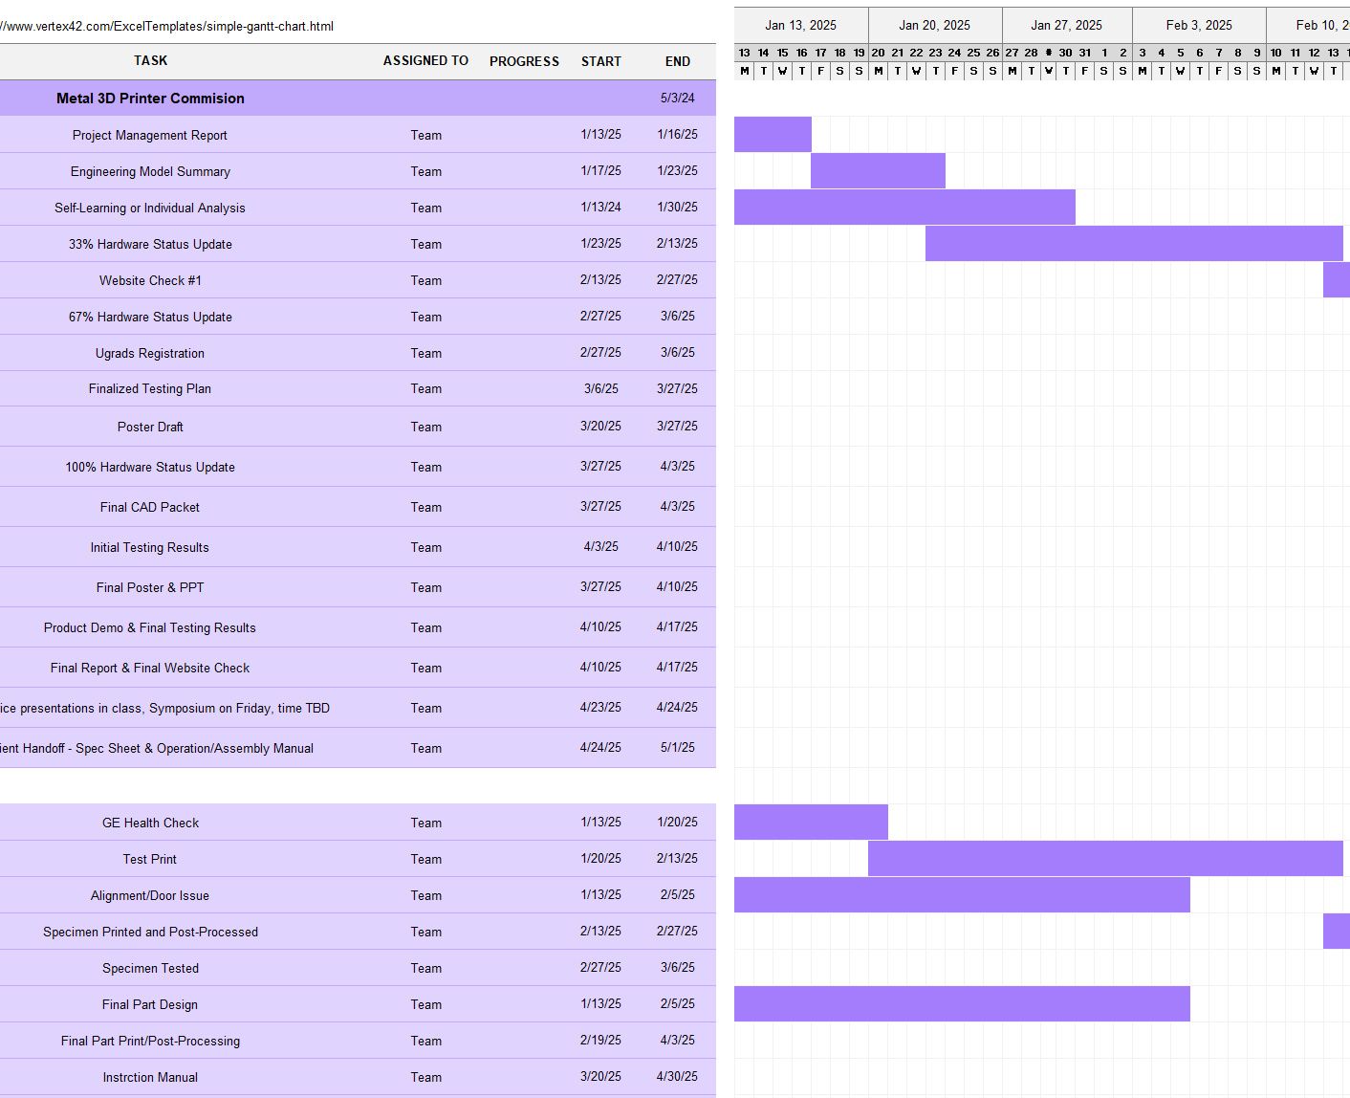
Figure 1: Spring 2025 Gantt Chart

In Figure 1 above, the Gantt chart starts at the top with the capstone deliverables from the beginning of the spring 2025 semester. The deliverables at the bottom section of the chart are specific project deliverables and proposed deadlines. The major tasks to complete at the beginning of the semester working backwards from the first hardware status update are as follows:
- 33% Hardware Status Update (2/13/25)
  - This is to ensure that the capstone teams are physically realizing their project, showing that they have at least one third of the manufacturing completed.
- Specimen Printed and Post-Processed (2/12/25)
  - This is a specific project deliverable in which we want to have our tensile testing specimen printed, post-processed, and ready for testing.
- Alignment/Door Issue (2/5/25)
  - The printer issues need to be diagnosed and repaired by the time we need to print the tensile test specimen. This will ideally be addressed by the GE Health Check earlier in the semester.
- Final Part Design (2/5/25)
  - We plan to finish working on the design for our final part and assembly by this time to focus our full attention on learning how to operate the machine. Our optimized models should be complete by then.
- Self-Learning or Individual Analysis (1/30/25)
  - Capstone deliverable in which we will be performing individual self-learning tasks and writing reports on them to aid with the progress of the project.
- Test Print (1/27/25)
  - By this time, we will have started printing on the machine, keeping an eye out for any issues beginning to learn the software and material handling procedures.
- Engineering Model Summary (1/23/25)
  - Comprehensive review of our engineering model thus far.
- Colibrium Additive Health Check (1/20/25)
  - This is a planned visit from the metal printer company where they will ensure our printer is running properly and is safe to print on and will install an upgrade to the build elevator. The exact date of the visit is yet to be determined; however, we hope for it to be completed by this time.
- Project Management Report (1/16/25)
  - Final draft of this report due.

3. Purchasing Plan
This section details the purchasing plan moving forward in the project.
- GE Heath and Service Check
  - During our Spring Semester, one of the first things we plan on ordering is a Health Check from Colibrium Additive to make sure the printer is working properly and to install any needed upgrades. The printer had a known issue with the elevator malfunctioning that this check could provide.
- Powder Stock
  - Although we have ample supply now, we are bound to eventually run out of the SS 316L stock we plan on testing with. As a result, we will need to plan on acquiring more powder.
- Build Plate
  - We plan on acquiring a single build plate for use within the machine. Seeing as the price of a single plate, which wears down with use, is a three-figure number, we will plan on manufacturing more in the future rather than spending money on more.
- Argon Gas Supply
  - Another material that is used during the printing process is argon, which is expended rather quickly during a print. We plan on developing a method to acquire the material rather efficiently, seeing as it would need to be supplied to the lab quite often. We will be consuming this material at a much faster rate than the others, so it is imperative that this is accomplished soon.
- Computer
  - The user manual for the printer includes a disk with the Materialise Magics slicing software, which will be required to print any CAD drawings or parts made for the machine. As a result, Dr. Cioconel thought it best to acquire a dedicated computer from ITS for using Magics.

4. Manufacturing Plan
This section details the manufacturing plan moving forward in the project.
- First Prints
  - One of the first things the team plans on doing with the printer as soon as it is fully operational is to print whatever is already on the machine. According to Andrew Wessman, the printer may come with files already loaded on the machine from the previous owner and prepared to print, so to discover whether the printer is fully functional it would be wise to use these.
  - After acquiring the dedicated computer to use Magics on, we plan on creating our own sliced files to try and print on the machine. This includes a Benchy Boat or some sort of miniature to determine the resolution of the machine.
- Specimen Samples
  - One of our required deliverables for the project is to stress test specimens from the printer to determine how their strength compares to parts that were normally manufactured. This will be accomplished by comparing the results of a normally machined specimen that is typically used for tests, a printed piece of stock that will be machined to specifications, and a purely printed specimen that follows specifications.
- Final Prints
  - The final prints will most likely be a topology-optimized part of our own design, most likely a miniaturized skateboard truck to put onto a hand board or Tech deck of some sort. If possible, we hope to produce a part that another team may need.
- Build Plates
  - Removing prints from the build plate requires the use of a buzz saw of some sort. During the process, the part is more or less welded to the build plate and requires extra support in order to remove it without damaging the part. However, this also requires build plates to be machined down to remove any excess metal on the surface.
  - Due to the constant wear on the build plates, it will be needed to change them often. Although more plates can be purchased from the manufacturer, they run at about 220 dollars a plate, which is an expensive endeavor considering the other materials consumed during the printing process are similarly expensive. As such, we plan on coordinating with the machine shop to potentially manufacture our own plates at the school.

5. Capstone Deliverable Alterations
5.1 Hardware Status Updates
We would like to discuss what these status updates mean for our project, as we are not spending the entire semester building our design from last semester like most capstone projects are.

These status updates could instead be used to check in with our project deliverables as laid our in our Gantt chart for this semester. Each hardware status update corresponds to major progress steps we intend to have completed by those times. Proposed alternate updates are as follows:
- 33% Hardware Status Update → Machine up and running, multiple test prints printed
- 66% Hardware Status Update → Tensile test specimen printed and tested
- 100% Hardware Status Update → Final part printed and post-processed, and instructional manual started

